Task 2
In Task 2, I created and updated my digital profiles on platforms such as GitHub and LinkedIn. The purpose of this task was to build a professional online presence, which is very important for students today. These platforms help in showcasing skills, projects, and achievements.
On GitHub, I created my profile and added basic details such as my name, branch, and a short introduction about myself. GitHub is useful for storing and sharing projects, and it can be used as a portfolio for future opportunities. On LinkedIn, I completed my profile by adding my education details, including my college name, course, and expected graduation year. LinkedIn helps in connecting with professionals and exploring internship and job opportunities.
I also took screenshots of my profiles and added them to the project folder as required. Through this task, I understood how important it is to maintain a clean and professional digital identity. In the coming years, I plan to use these platforms to upload my work, learn new skills, and build connections that will help me in my career.

GitHub account
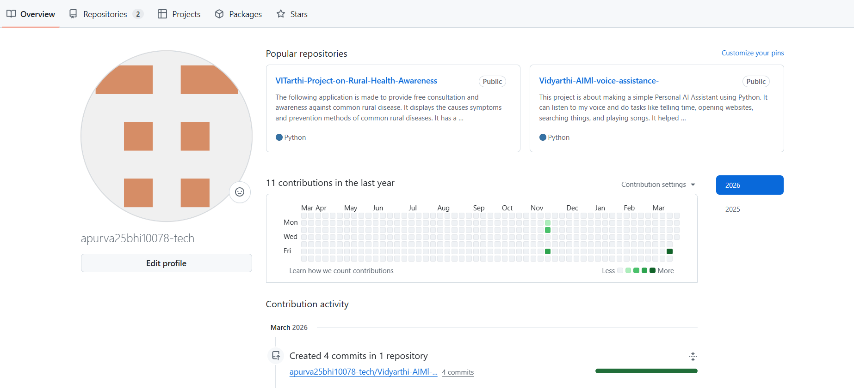

LinkedIn
